Milestone Three
Modeling and Evaluation

Michael Surdek
Southern New Hampshire University
DAT 690: Capstone in Data Analytics
Professor Arman Kanooni
September 25, 2022
Modeling Phase
After a preliminary pass at understanding and preparing the data, selected inputs can be fed into a logistic regression model using TidyModels in R.
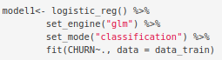

This predictive model can provide both the likelihood that a specific customer will or will not churn as well as a simple yes or no prediction along the same lines. According to the preliminary results, these are the most important variables for predicting churn and the impact that changes in each variable have on the likelihood of churn.
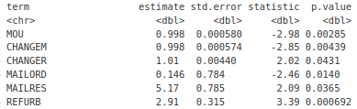

Applying the model to some of the data that was not used for training provides an idea of how well the model can predict customers who may churn going forward. This table shows the customer ID, whether or not they actually churned according the original data, the model’s yes or no prediction and its probabilities for each target category.
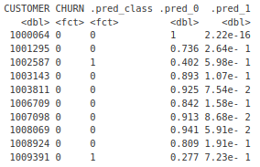

This is high-quality data that can actually be used by the customer retention team to identify the customers who are most likely to churn and to proactively contact them with the hopes of retaining their business. Some additional data produced by the model that could be of use to the retention team include confidence intervals of the predictions and local importance, which can highlight the main reasons that the model believes that a specific customer will or will not churn.

Evaluation Phase
There are many metrics that can help to analyze how well the model predicts customers who are likely to churn. With the data on which it was trained, the model resulted in 73% accuracy, which shows it was successfully fit to the selected customer data. However, the accuracy reduced to only 65% when the model was applied to the testing data that was not used to train the model. This value will be more important when it comes to providing value to GE and their retention team.
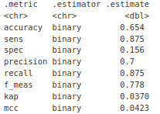

A confusion matrix reveals that the model correctly predicts 126 out of 144 who did not churn, but only successfully idenntifies 10 of the 64 customers who did churn. This is an area of concern because GE does not want to let customers slip through their fingers. In this case, they would prefer that a customer is identified as likely to churn even if they do not actually churn, because it ensures that they will be contacted by the retention team. The specificity value of only 15% is the main area for improvement at this stage of the model.
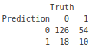

When the model does a better job at identifying customers who are likely churn, one metric that should significantly improve is ROC AUC. This metric quantifies how well the model predicts true positive cases in terms of the cost of predicting a false positive case. On the training data, ROC AUC was over 73%, which means that there are signals in the training data that are associated with customers who churn. However, those signals do not seems to carry over to the unseen data, as the ROC AUC on the testing data is only 53%.
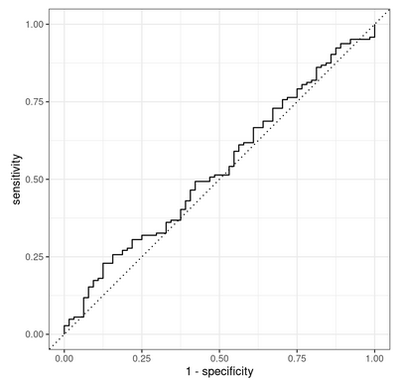

The goal is to get the ROC AUC curve closer to the top left of the chart and farther from the diagonal line in the middle. If this happens, then the model will do a better job at predicting customers who are likely to churn and thus provide more value to GE.

